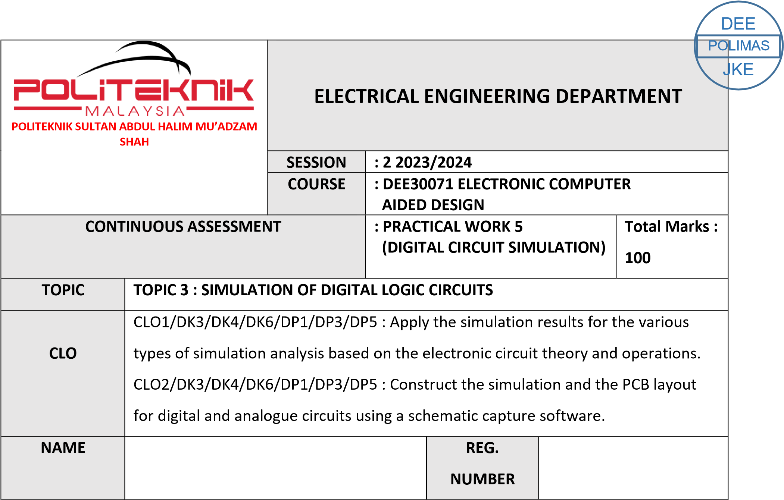

03DET22F1043

CHONG KHENG CHEN

|  |  |  |
| --- | --- | --- |
| CLO1 (C3, PLO1) | COGNITIVE ASSESSMENT  (20 %) |  |
| CLO2 (P4, PLO5) | PSYCHOMOTOR ASSESMENT  (80 %) |  |
|  | TOTAL MARKS  (100%) |  |

**\*Refer to Rubric**

|  |  |
| --- | --- |
| **1** | **LEARNING OUTCOMES (LO):**    1. Apply the simulation results for the various types of simulation analysis based on the electronic circuit theory and operations |
| **2** | **OBJECTIVE :**     1. Apply the simulation result for digital simulation analysis using the Truth Table. 2. Construct the digital schematics circuit and simulate the circuits using a particular simulation packages. |
| **3** | **THEORY :**    A digital circuit simulation is an event-driven, time-domain simulation. You can define an arbitrary time step for your live digital simulation and increment the simulation time discretely, one step at a time, and manually change the state of the input(s) at each time step.  Through the experiment, students can learn the concept of digital circuit simulation, applications of logic level simulation for combinational and sequential logic circuits. Logic inputs can be represented as Digital Clocks and output can be obtained by performing Time Domain Analysis. The analysis produced is displayed as a timing diagram and later can be represented into a Truth Table. |
| **4** | **EQUIPMENT / TOOLS / SOFTWARE :**   1. PC workstation 2. Related software |

|  |  |  |  |  |  |  |  |  |  |  |  |  |  |
| --- | --- | --- | --- | --- | --- | --- | --- | --- | --- | --- | --- | --- | --- |
| **5** | **PROCEDURE :**  Draw and simulate this logic circuit below:  i. Circuit A: SYNCHRONOUS COUNTER ii. Circuit B: SHIFT REGISTER    **PART A: DIGITAL CIRCUIT**  Construct the Truth Table for each circuit based on timing diagram obtained in Result section.    **PART B: DIGITAL CIRCUIT SIMULATION**  Sketch the timing diagram for each circuit in result section.      Figure 5.1: Circuit A (SYNCHRONOUS COUNTER)       |  |  | | --- | --- | | Jc | A | | Kc | A | | Jb | 1 | | Kb | C | | Ja | C | | Ka | C | |
|  | Set the Digclock such as below :    DSTM1  Ontime = 0.5s  Offtime = 0.5s  Oppval = 1    DSTM2  Ontime = 20s  Offtime = 0.1us  Oppval = 1    DSTM3  Ontime = 20s  Offtime = 0.1us  Oppval = 1    Click **Menu Bar**, select **Analysis**\**Setup**. Click check box **Transient** to enable it and set the specifications as shown below:    Print Step : 0s  Final Time : 20s  No Print Delay : 0  Step Ceilling : 0    Click check box **Digital Setup** and click at **All 1**.  Simulate the circuit and observe the output waveform.    Sketch the timing diagram for each circuit in result section. |

Figure 5.2:

Circuit B (SHIFT REGISTER)

DIG CLOCK SETTING

STIM1

SETTING

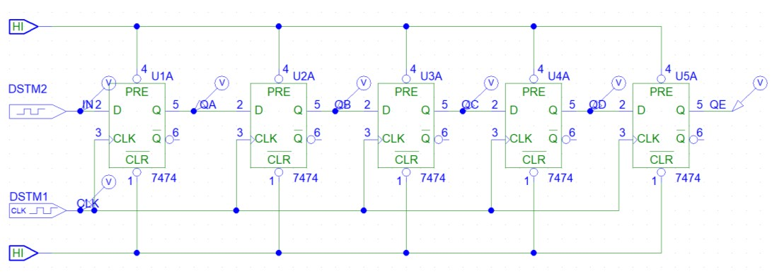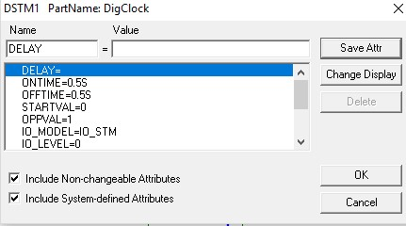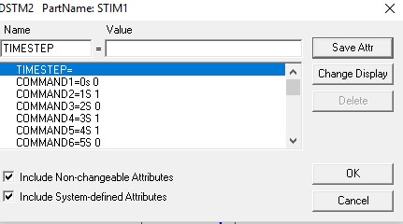

|  |  |
| --- | --- |
|  | Click **Menu Bar**, select **Analysis**\**Setup**. Click check box **Transient** to enable it and set the specifications as shown below:    Print Step : 0.5s  Final Time : 20s  No Print Delay : 0  Step Ceilling : 0 |
| **6** | **RESULT :**   1. Timing diagram        1. Table 5.1: Truth Table for Circuit A (SYNCHRONOUS COUNTER)  |  |  |  |  | | --- | --- | --- | --- | | clock | Qa | Qb | Qc | | **0** | **0** | **0** | **0** | | **1** | **0** | **1** | **1** | | **2** | **1** | **0** | **1** | | **3** | **1** | **1** | **0** | | **4** | **0** | **1** | **0** | | **5** | **0** | **1** | **1** | | **6** | **1** | **0** | **1** | | **7** | **1** | **1** | **0** | | **8** | **0** | **1** | **0** | | **9** | **0** | **1** | **1** | | **10** | **0** | **0** | **1** | |

|  |  |  |  |  |  |  |  |  |  |  |  |  |  |  |  |  |  |  |  |  |  |  |  |  |  |  |  |  |  |  |  |  |  |  |  |  |  |  |  |  |  |  |  |  |  |  |  |  |  |  |  |  |  |  |  |  |  |  |  |  |  |  |  |  |  |  |  |  |  |  |  |  |  |
| --- | --- | --- | --- | --- | --- | --- | --- | --- | --- | --- | --- | --- | --- | --- | --- | --- | --- | --- | --- | --- | --- | --- | --- | --- | --- | --- | --- | --- | --- | --- | --- | --- | --- | --- | --- | --- | --- | --- | --- | --- | --- | --- | --- | --- | --- | --- | --- | --- | --- | --- | --- | --- | --- | --- | --- | --- | --- | --- | --- | --- | --- | --- | --- | --- | --- | --- | --- | --- | --- | --- | --- | --- | --- |
|  | 1. Timing diagram        1. Table 5.2: Truth Table for Circuit B (SHIFT REGISTER)  |  |  |  |  |  |  | | --- | --- | --- | --- | --- | --- | | CLOCK | QA | QB | QC | QD | QE | | 0 | 1 | 1 | 1 | 1 | 1 | | 1 | 0 | 1 | 1 | 1 | 1 | | 2 | 1 | 0 | 1 | 1 | 1 | | 3 | 0 | 1 | 0 | 1 | 1 | | 4 | 1 | 0 | 1 | 0 | 1 | | 5 | 1 | 1 | 0 | 1 | 0 | | 6 | 0 | 1 | 1 | 0 | 1 | | 7 | 1 | 0 | 1 | 1 | 0 | | 8 | 1 | 1 | 0 | 1 | 1 | | 9 | 1 | 1 | 1 | 0 | 1 | | 10 | 0 | 1 | 1 | 1 | 0 | |
| **7** | **DISCUSSION :**  To fulfill your objectives, first, utilize a Truth Table to simulate digital logic by defining inputs and outputs, then analyze the results. Next, employ a simulation package to construct the digital circuit, configure inputs according to the Truth Table, run simulations, and iterate on the design if necessary. Discussion should encompass circuit details, insights gleaned from simulations, and any encountered challenges. |

|  |  |
| --- | --- |
| **8** | **CONCLUSION :**  In summary, this project successfully applied digital simulation analysis using Truth Tables and constructed digital schematic circuits for simulation using specialized software packages. Through this process, we gained valuable insights into circuit behavior and validated our designs against specified criteria. This underscores the importance of simulation in digital circuit design, facilitating iterative refinement and optimization for more robust systems. |

|  |  |  |  |  |  |  |  |  |  |
| --- | --- | --- | --- | --- | --- | --- | --- | --- | --- |
| **PRACTICAL WORK 5: DIGITAL CIRCUIT SIMULATION** | | | | | | |  | A | B |
|  | **MATRIX NUMBER** | | | **NAME** | | |  |
|  |  | | |  | | |  |
| **A** | 03DET22F1043 | | |  | | | CHONG KHENG CHEN |  |  |
| **B** |  | | |  | | |  |
| Course Learning  Outcomes(CLO)/  Learning Domain Cluster (CLS) | | Circuit | Skills /  Aspects | | Very Poor | Satisfactory | Very Good | Marks | |
| 1 | 2 | 3 |
| CLO 1 : Apply the simulation results for the various types of simulation analysis based on the electronic circuit theory and operations.    CLO 2: Construct the simulation and the PCB layout for digital and analogue circuits using a schematic capture software.    CLS 1:  Knowledge &  Understanding    CLS3a :  Practical skill | | PART  A    5.1 | **Draw circuit:** Student able to draw the circuit same as given. | | Able to draw the circuit with assistance. | Good to draw the  circuit moderately with little assistance. | Excellent to draw  the circuit effectively. | /3 | /3 |
| **Input and analysis setup:** Student able to set the input and transient. | | Able to set the input and transient with assistance. | Good to set the input and transient moderately with little assistance. | Excellent to set the input and transient effectively. | /3 | /3 |
| **Voltage and current display:** Student able to simulate the circuit and observe the result correctly. | | Able to simulate the circuit and observe the result correctly with assistance. | Good to simulate the circuit and observe the result correctly with little assistance. | Excellent to simulate the circuit and observe the result effectively. | /3 | /3 |
| **Timing Diagram:**  Student able to obtain the output for Qa, Qb and Qc correctly. | | Able to obtain the output Qa, Qb and Qc correctly with assistance. | Able to obtain the output for Qa, Qb  and Qc correctly  with little assistance. | Able to obtain the output for Qa, Qb and Qc effectively. | /3 | /3 |
|  | | | | |  | /12 | /12 |
| PART  B    5.2 | **Draw circuit:** Student able to draw the circuit same as given. | | Able to draw the circuit with assistance. | Good to draw the  circuit moderately with little assistance. | Excellent to draw  the circuit effectively. | /3 | /3 |
| **Input and analysis setup:** Student able to set the input and transient. | | Able to set the input and transient with assistance. | Good to set the input and transient moderately with little assistance. | Excellent to set the input and transient effectively. | /3 | /3 |
| **Voltage and current display:** Student able to simulate the circuit and observe the result correctly. | | Able to simulate the circuit and observe the result correctly with assistance. | Good to simulate the circuit and observe the result correctly with little assistance. | Excellent to simulate the circuit and observe the result effectively. | /3 | /3 |

# PRACTICAL SKILLS PSYCHOMOTOR ASSESMENT - (80%)

|  |  |  |  |  |  |
| --- | --- | --- | --- | --- | --- |
| **NO.** | **STUDENT’S NAME** | **PART**  **A**    **(5.1)** | **PART**  **A**    **(5.2)** | **Total:** | **80%** |
| **(24 marks)** |
| **A** | **CHONG KHENG CHEN** | /12 | /12 | /24 | /80 |
| **B** |  | /12 | /12 | /24 | /80 |

# PRACTICAL WORK COGNITIVE ASSESSMENT - (REPORT 20%)

|  |  |  |  |  |  |  |  |
| --- | --- | --- | --- | --- | --- | --- | --- |
|  |  | **Timing Diagram:**  Student able to obtain the output for QA, QB, QC, QD and QE correctly. | Able to obtain the output for QA, QB, QC, QD and QE correctly with assistance. | Able to obtain the output for QA, QB, QC, QD and QE correctly with little assistance. | Able to obtain the output for QA, QB, QC, QD and QE effectively. | /3 | /3 |
|  | |  |  |  | /12 | /12 |

|  |  |  |  |  |  |  |  |
| --- | --- | --- | --- | --- | --- | --- | --- |
| **PART A TRUTH TABLE** | | **PART B TIMING DIAGRAM** | | **Discussion** | **Conclusion** | **TOTAL** | **20%** |
| 5.1 | 5.2 | 5.1 | 5.2 |  |  |  |  |
| /10 | /10 | /10 | /10 | /10 | /10 | /60 | /20 |

# TOTAL MARKS

|  |  |  |  |  |
| --- | --- | --- | --- | --- |
| **NO.** | **STUDENT’S NAME** | **COGNITIVE**  **ASSESSMENT**  **(20 %)** | **PSYCHOMOTOR**  **ASSESMENT (80 %)** | **Total:** |
| **(100 %)** |
| **A** | **CHONG KHENG CHEN** | /20 | /80 | /100 |
| **B** |  | /20 | /80 | /100 |